1.Find total quantity sold by each salesperson.

QUERY : select sales_person, sum(quantity) as total_quantity_sold from sales

group by

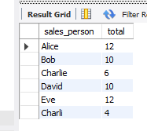

2.Find salespersons who sold more than 5 items in total.

QUERY :Select sales_person from sales where ‘quantity’>5;

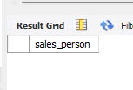

3.Find number of products sold by each salesperson.

QUERY : select sales_person,count('Product') as total_products_ from es group by sales_person ;

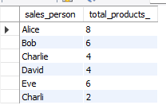

4.List regions where total sale amount exceeded $1000.

QUERY : select region , sum(SaleAmount) as total_sales from sales group by region having sum( Saleamount)>1000;

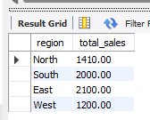

5. Show salespersons who made more than 2 sales transactions.

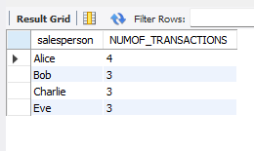

QUERY : SELECT salesperson ,count(*) as NUMOF_TRANSACTIONS from Sales group by salesperson having count(*)>2;

6. Find total sale amount by product, and show only products that made over $500 in sales.

QUERY : select Product ,sum(SaleAmount) as total_sales from Sales group by Product having sum(SaleAmount)>500;

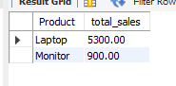

7.Show the total quantity sold of each product in each region.

QUERY: select Product ,sum(Quantity) as total_quantity_sold from Sales group by Product,Region ;

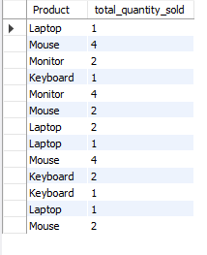

8.Find salespersons who sold more than 1 type of product.

QUERY : select salesperson from sales group by salesperson having count( distinct Product)>1;

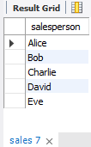

9.Find the average quantity per product sold per region, where the average is greater than 1.

QUERY: SELECT salesperson, region, SUM(saleamount) AS total_sales FROM Sales GROUP BY salesperson, region HAVING SUM(saleamount) > 500;

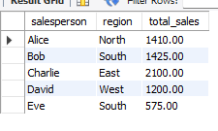

10.Show salespersons whose total sale amount is between $500 and $1500.

QUERY : select salesperson ,sum(saleamount) as total_saleamont from Sales group by salesperson having sum(saleamount) between 500 and 1000;

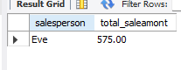

11.List top-performing products (more than 3 units sold in total).

QUERY : SELECT product ,sum(quantity) as total_quantity from sales group by product having sum(quantity)>3;

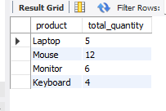

12.List salespersons who sold laptops.

QUERY :SELECT SALESPERSON FROM SALES WHERE PRODUCT='LAPTOP';

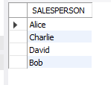

13.Find total sale amount per salesperson per region, only where it exceeds $500.

Query :SELECT salesperson, region, SUM(saleamount) AS total_sales FROM Sales GROUP BY salesperson, region HAVING SUM(saleamount) > 500;

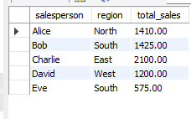

14.Find salespersons who sold at least 2 different products in a single region.

QUERY : SELECT product, COUNT(*) AS num_sales FROM Sales GROUP BY product HAVING COUNT(*) >= 2;

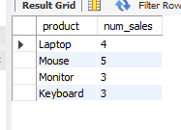

15.Find products that were sold in more than one region.

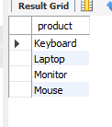

QYERY : SELECT product FROM Sales GROUP BY product HAVING COUNT(DISTINCT region) > 1;

16.Show total number of sales per product and hide products with fewer than 2 sales.

QUERY : SELECT product, COUNT(*) AS num_sales FROM Sales GROUP BY product HAVING COUNT(*) >= 2;

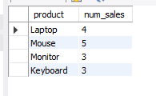

17.Find region-wise total quantity sold by each salesperson.

QUERY : SELECT region, salesperson, SUM(quantity) AS total_quantity FROM Sales GROUP BY region, salesperson;

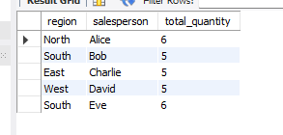

18.Find salespersons who made more than 3 transactions and total sales amount is over $1000.

QUERY : SELECT salesperson, COUNT(*) AS num_transactions, SUM(saleamount) AS total_sales FROM Sales GROUP BY salesperson HAVING COUNT(*) > 3 AND SUM(saleamount) > 1000;

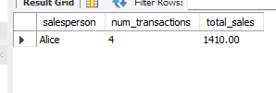

19.Find average sale amount per region and show only regions with average above $200.

QUERY : SELECT region, AVG(saleamount) AS avg_sale FROM Sales GROUP BY region HAVING AVG(saleamount) > 200;

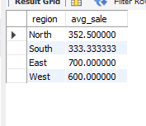

20.List regions and products where more than 3 units were sold.

QUERY : SELECT region, product, SUM(quantity) AS total_quantity FROM Sales GROUP BY region, product HAVING SUM(quantity) > 3;

